Name: Cargile, Christopher
Student access ID: 10059306
Project: JEdit
Change Number: 2
Date: 11/12/2013
Team Number: 2

“Edit Remote Files”

- Change Request:
The intention of the change request is to have created an FTP push/download utility for files (or ‘temp files’ in the case a not-yet-locally-saved buffer contains contents to be remotely stored). Since user-account-control permissions are necessary to upload/download from most FTP sites, the dialog will allow for the user to specify their login details, including the ftp-website, username, password, and final URL of the file being stored/retrieved at/from. As a technical note, overwrite is the default behavior for local and remote files if the nature of the circumstance requires it (ie: there is a match for the buffer-saved on the remote server or there is a local file by the same name as the file being retrieved). As either HTTP or FTP should be supported, but not necessarily both, FTP was chosen to carry out the networking-IO as a straight-forward, comprehensible external library hosted on Apache-Commons (commons-net-3.3.jar) accommodated the desired goal.

- Concept Location:
JRipples’ GREP analysis using the text query ‘Buffer’ presented a substantial number of classes containing matches. jEdit being the main class was chosen as a likely location to start, as it initializes the program and contains some methods that seem helpful/relevant (newFile(), loadFile(), etc):

Table 1. Classes visited during concept location.
# | File name | Tool used | Located? | Comments
1 | jEdit.java | Manual Exploration/JRipples GREP | No; jEdit is not to change | Unchanged; jEdit contains called methods for CR#2
2 | Buffer.java | JRipples GREP | No, Buffer is not to change | Unchanged; Buffer does not contain methods called or changed
3 | VFSFileChooser.java | JRipples GREP (matching) but Eclipse JAVA Search used moreso | No, <- will not change. | Unchanged; VFSFileChooser seemed likely as cousin-candidate for FTPFileChooser but will not be necessary
4 | Actions.xml | Past Experience | Yes; CR will affect this file | Changed; CR#2 will require changing this file.
5 | jEdit_gui.props | Past Experience | Yes; CR will affect this file | Changed; CR#2 will require changing this file

- Impact Analysis:
Part of the difficultly implementing FTP remote editing/save capability stems not only from comprehending and implementing JEdit’s unique implementation of the Swing GUI-API, but also from tying it into a previously not-understood Buffer/View management system. A future area for work in the CR #2 regard, might involve implementing an FTP-FS (FTP filesystem) module with associated helper classes (ie: FTPFile,FTPFileFilter,FTPFileManager…) since VFS has this type of module for local filesystems. Dave Coons provided some help as the team member performing finalization for our code base and noted that the classpath referenced an outdated .jar file (thank to Dave for correcting the version listed in our .classpath file).

Table 2. Classes visited during impact analysis.
# | Class name | Tool used | Impacted? | Comments
1 | BufferInsertRequest.java | JRipples GREP search | No; | Unchanged; tho this class is interesting because it is delegated to handle IO on buffers
2 | VFSFileChooserDialog | JRipples GREP/Eclipse JAVA Search | Yes; | Unchanged; this class is not directly changed but its behaviours mirrored to extend EnhancedDialog instance
3 | VFS.java | Eclipse JAVA Search/ JRipples GREP | No; | Unchanged; this class interacts with local FS which CR#2 may utilize but NOT as part of remote-file capability

- Learning process:.
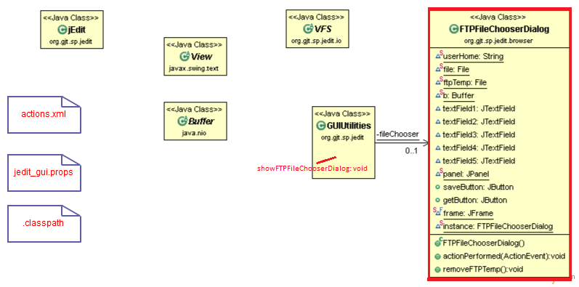
Figure 1 CR#2 class diagram

- Description of the implementation:
While jEdit, View, Buffer, and VFS were unchanged in the implementation of this feature, they seem so essential to any CR associated with the jEdit GUI and/or text-editing capability that they are included in the class diagram for easier comprehension. The bulk of the changes facilitating the completion of my CR derive from the classes where file management and buffer-related operations occur (aside from the message-bus and beanshell interpreting – but those can be considered more of system-level/architectural concerns, as opposed to classes needing to be discussed for the purpose of this impact analysis explanation). The classes where the buffer updates, file-IO, and, to a certain extent, the GUI manipulation occur can be isolated to the classes depicted, above. Actions.xml specifies Java methods called in a static fashion so that they can be interpreted by beanshell (in a dynamic fashion – to accommodate run-time binding, per beanshell’s website…), in actions.xml’s case for the purpose of associating GUI actions with the event-handling mechanisms that jEdit provides. GUIUtilities.showFTPFileChooserDialog() was a natural enhancement that could be incorporated alongside other actions.xml’s other eventListeners. The rest of the classes depicted are shown as new or changed for the functional implementation as they are: the properties file (also tied to GUI, as explained in the Phase 1..Report.doc file), the .classpath file being changed to accommodate the new, aforesaid added .jar file, and FTPFileChooserDialog.java, which implemented the JPanel and FTP/networking-IO behavior to finally address the remaining behavior for facilitating the CR. As discussed in the presentation, to make sense of the Swing-API complexity, a GroupLayout layout manager was applied, after studying available layout managers revealed it was understandable & practical for the CR.

- Sources: http://beanshell.org , Oracle's Visual Guide to Layout Managers website

- Highlighted Source Code:

